**Use Case 1- Did you mean search / Typo Search**

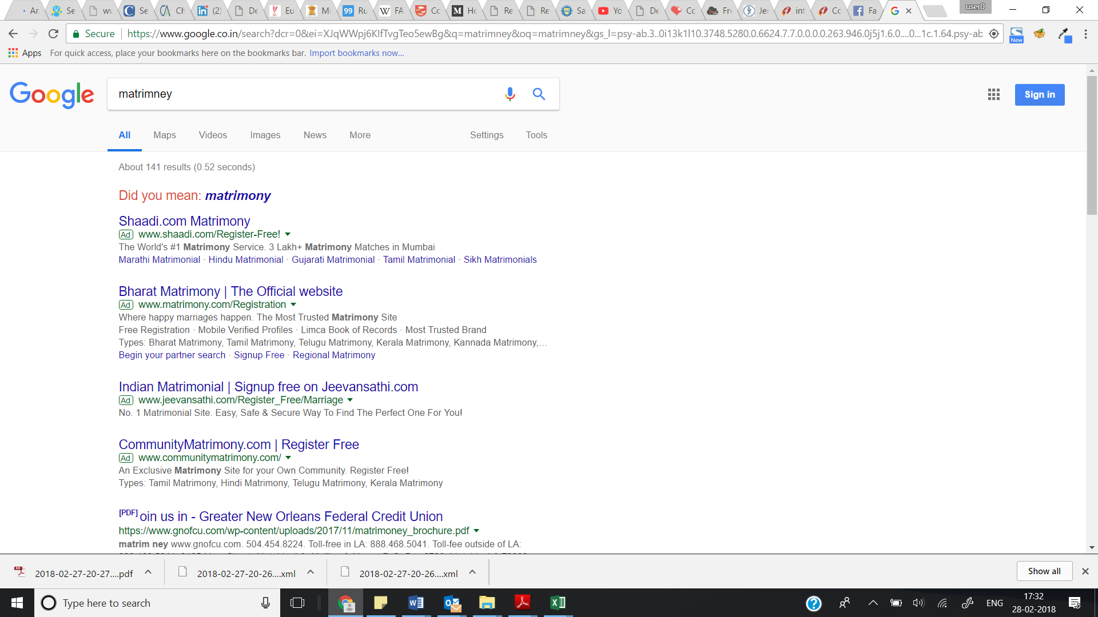

**Use Case 2 - Short Forms**

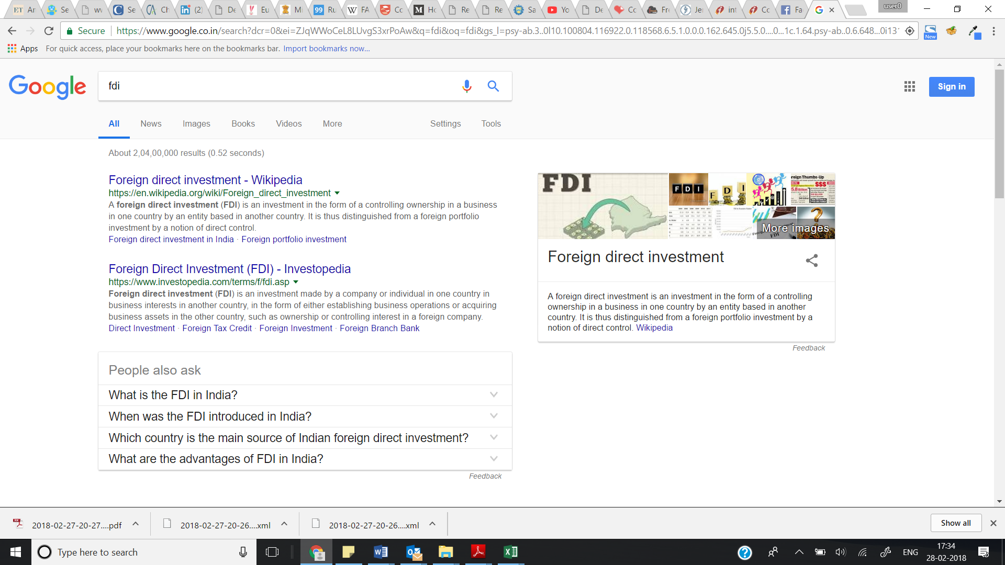

**Use Case 3 – Ranking Search**

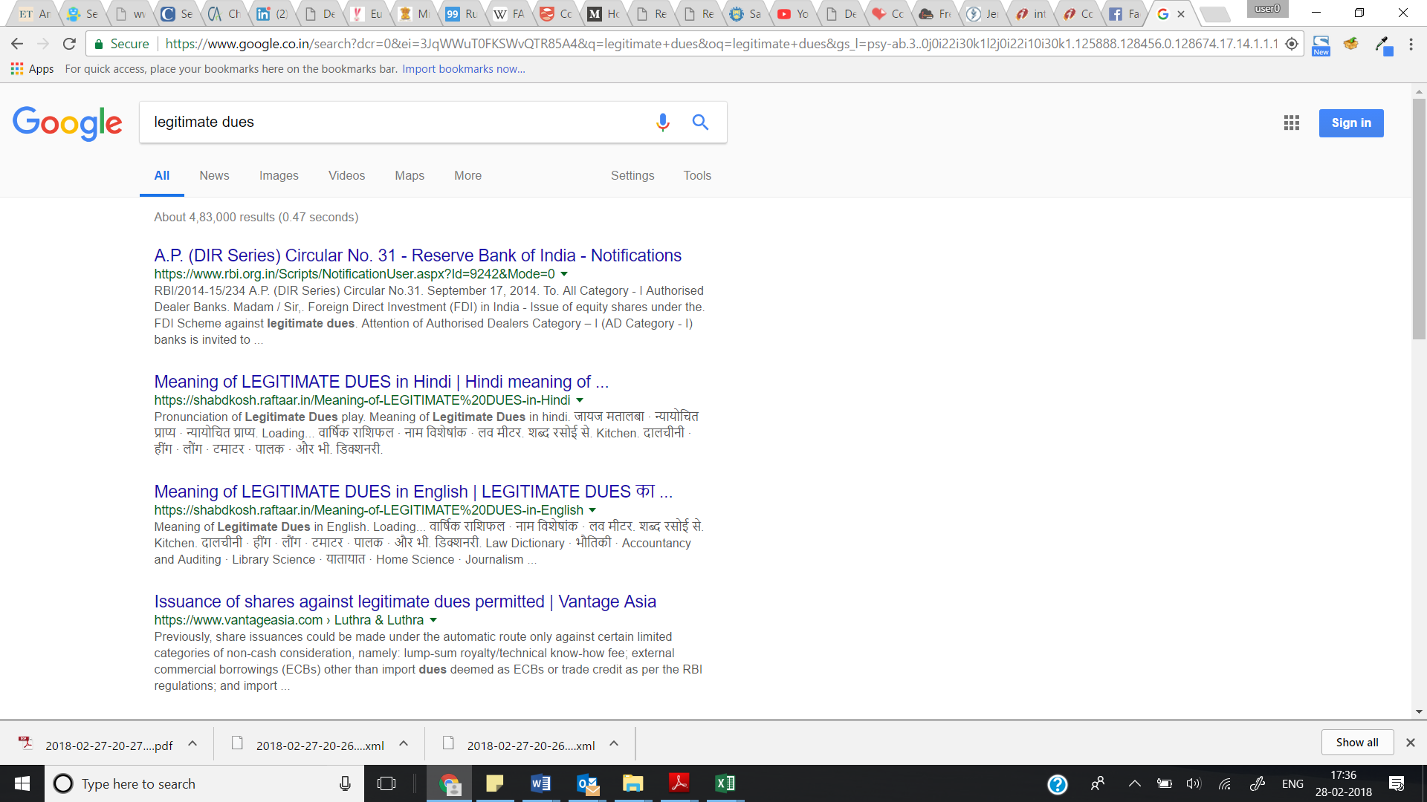

**Use Case 4 – Ranking Search**

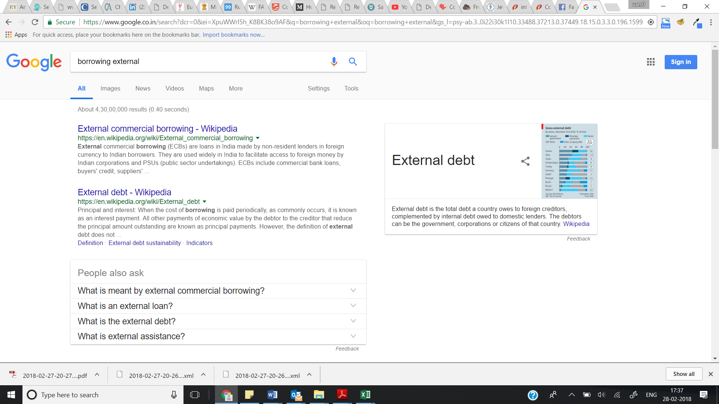

**Use Case 5 – Autocomplete & Phrase Complete option**

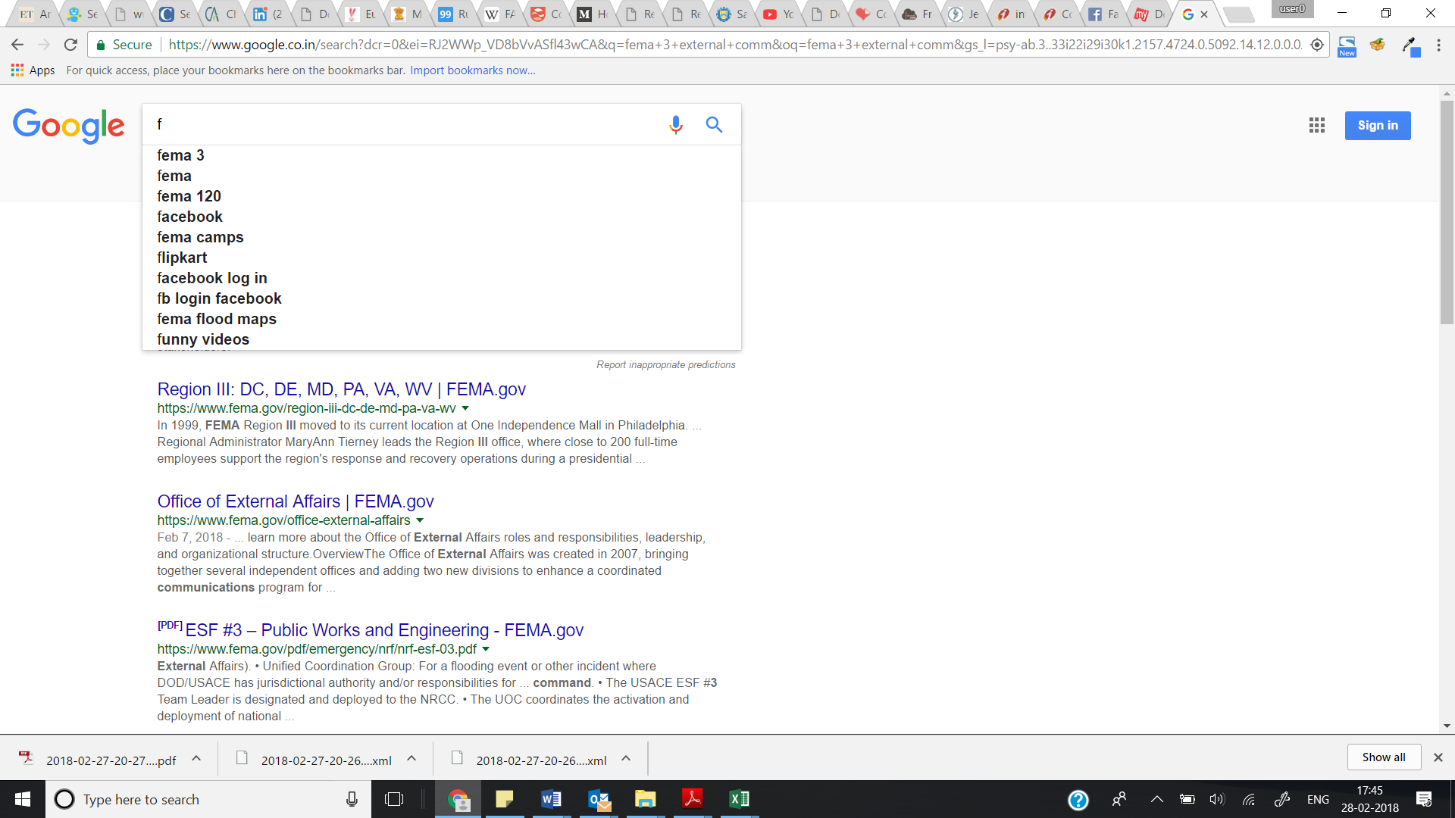

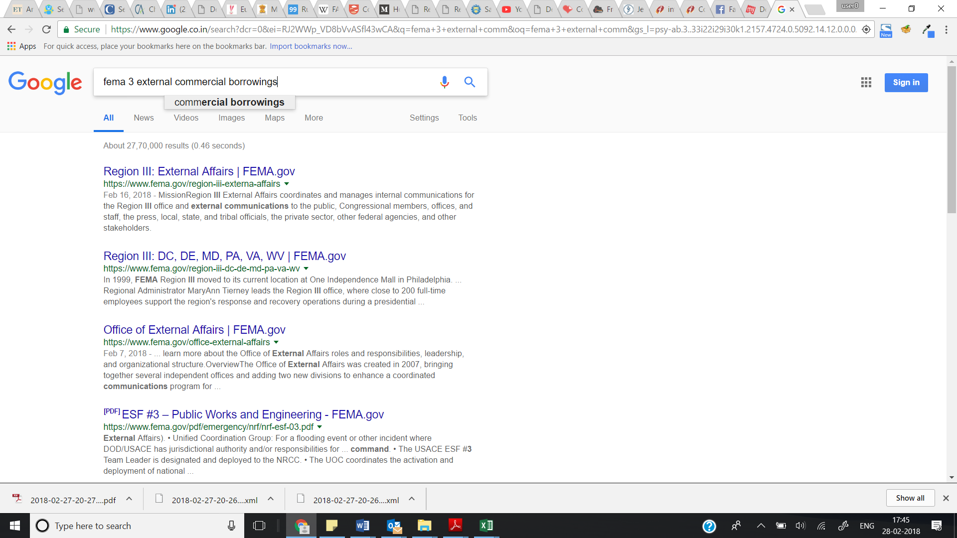

**Use Case 6 – Removal of special Characters**

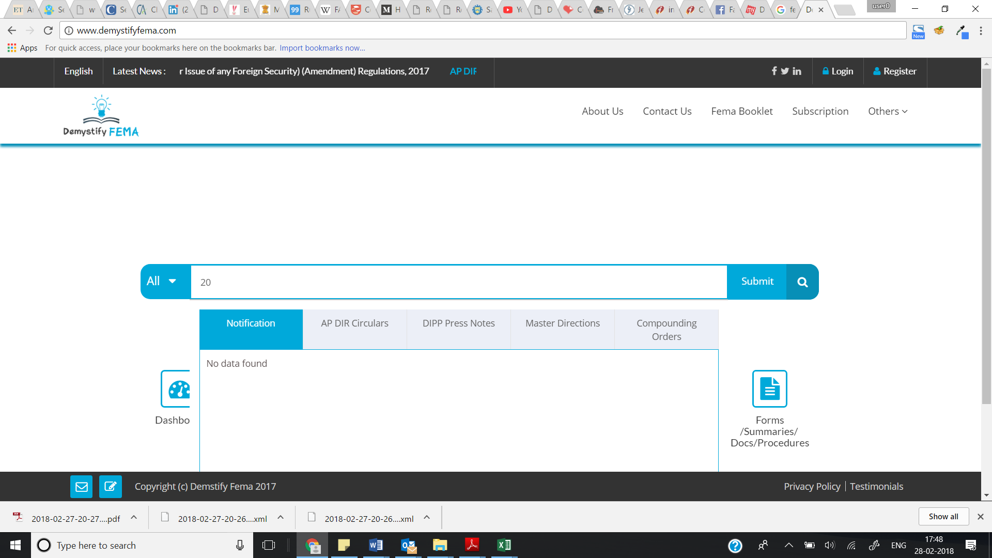

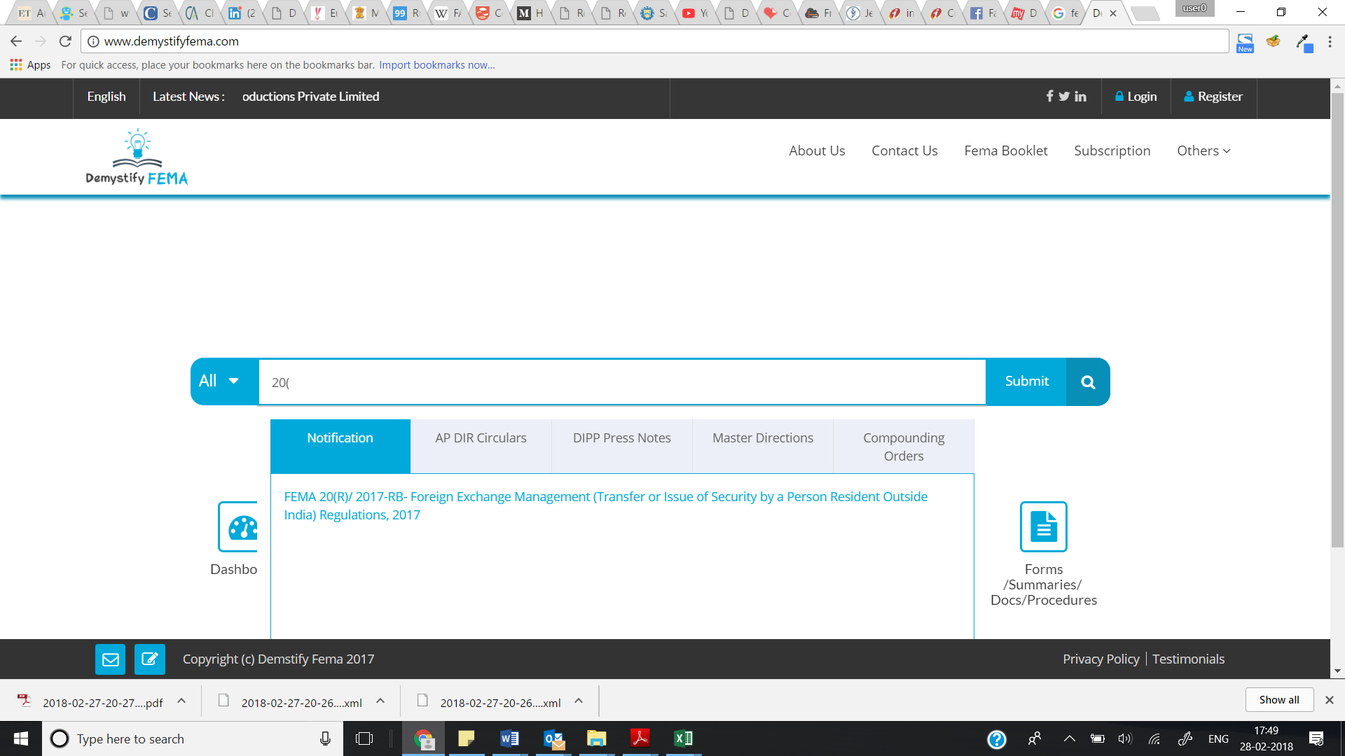

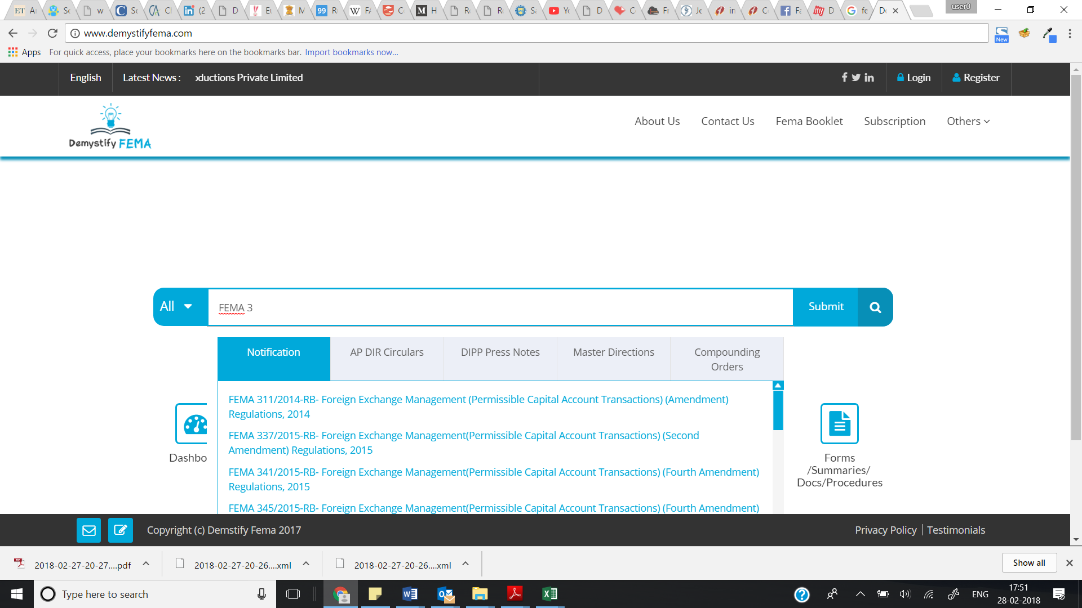

**Use Case 6 – Implies Search**

**On typing External – it should show FEMA 3 (we need to build Index dictionaries)**

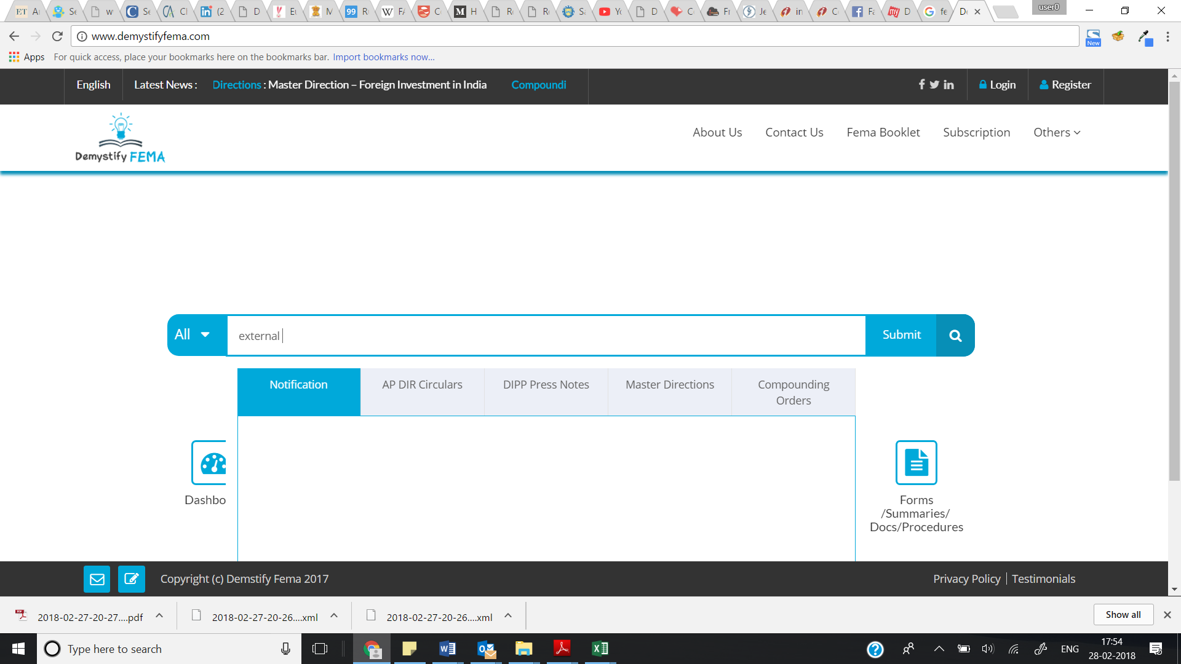

**Use Case 7 – Phrase Search**

**“issuing convertible notes” – look at the 4th result in the screenshot**

